**Report about Blackout inquiry submitted by NEPRA**

**Introduction:**

On 23 January, 2023 there was a massive power breakdown in our country including south (Generation side) and north (Load side). System frequency goes up to 50.7 Hz caused load and voltage variation on south side which contain our maximum generation. As a result, 500kV kV line tripped which result in isolation of North and South system followed by HVDC system blocked.

**Causes and Faults which resulted in cascade tripping and system collapse**

Induction of power generation at South and reduction of generation at North caused oscillations in the system which gave rise to power swing. Power swing could not be controlled due to non- operation of out of step protection devices. Hence in the South initially over frequency and later under frequency, whereas only under frequency occurrence in the North caused in the cascaded tripping’s of lines and power houses which resulted in total power blackout/breakdown in the country.

**Findings:**

* Low Frequency Oscillations
* Commutation Failures
* The failure of over frequency tripping at port Qasim

**Low Frequency Oscillations** are evident from all the power plants which may be attributed to complexities of the power system, weak transmission network, weak damping system and harmonics induced due to inverter-based generation.

**Commutation Failure** resulted in sudden power loss in HVDC link. 350 commutation failure in HVDC have been witnessed.

**The Failure of Over-Frequency Tripping at Port Qasim**: After the splitting event, frequency of southern region went beyond 51.5 Hz. Port Qasim did not trip at it's designed over frequency trip setting i.e., 51.4 Hz [Inst. trip], instead it run backed slowly. This failure of 620 MW tripping of Port Qasim, resulted in sustained over- frequency in south region.

**Restoration problems:**

The restoration process took almost 20 hours which is more than expected. Following is the reason;

* As we know in our country, lack of availability of black start facility. In northern region only Tarbela, Mangla and Warsak power stations and in the southern region Uch-I power station have this facility.
* Uch-I power station remain stable in island mode after its starting but in northern part tarbela did not.
* Tarbela power station doesn’t synchronized with national grid and tripped multiple times after synchronization of Mangla and Warsak station, Tarbela took its load.
* The lack of SCADA and remote operations has significant impact on the restoration process of the power system.

**HVDC Converter stations (Matiari and Lahore) event witnessed.**

**Summary of the briefing given by HVDC, Matiari Converter Station is as under;**

* The rated capacity is 4000MW. The rated voltage is± 660kV, whereas the rated maximum current of each pole 3030A.
* 07:34:13:222, AC voltage started decreasing i.e. 478kV
* 07:34:15:568, FLC activation
* 07:34:16:130 first instant when FLC achieve 1000MW
* 07:34:29:987, Pole 1 block
* 07:34:30:001, Pole II block Power before Tripping was 2400MW
* AC voltage at the time of tripping was 46.6KV
* DC voltage at the time of tripping was +43KV

**Summary of the presentation given by HVDC, Lahore Converter Station is as under;**

* 07:34:30:258, Pole 1 block 07:34:30:270, Pole II block
* 07:34:14:895, Pole I Commutation Failure
* 07:34:14:895, Pole II Commutation Failure
* 07:34:30:241, AC voltage at Y Block=213kV (L-N) RMS 07:34:30:241, DC voltage at Y Block-226kV
* Commutation Failure occurred at low voltage indication
* Power before Tripping was 2400MW

**Out of Step Splitting Devices:**

Out of step protection devices have been installed at the different locations to solve the problem of system out of step between North and South power grid under extremely serious fault.

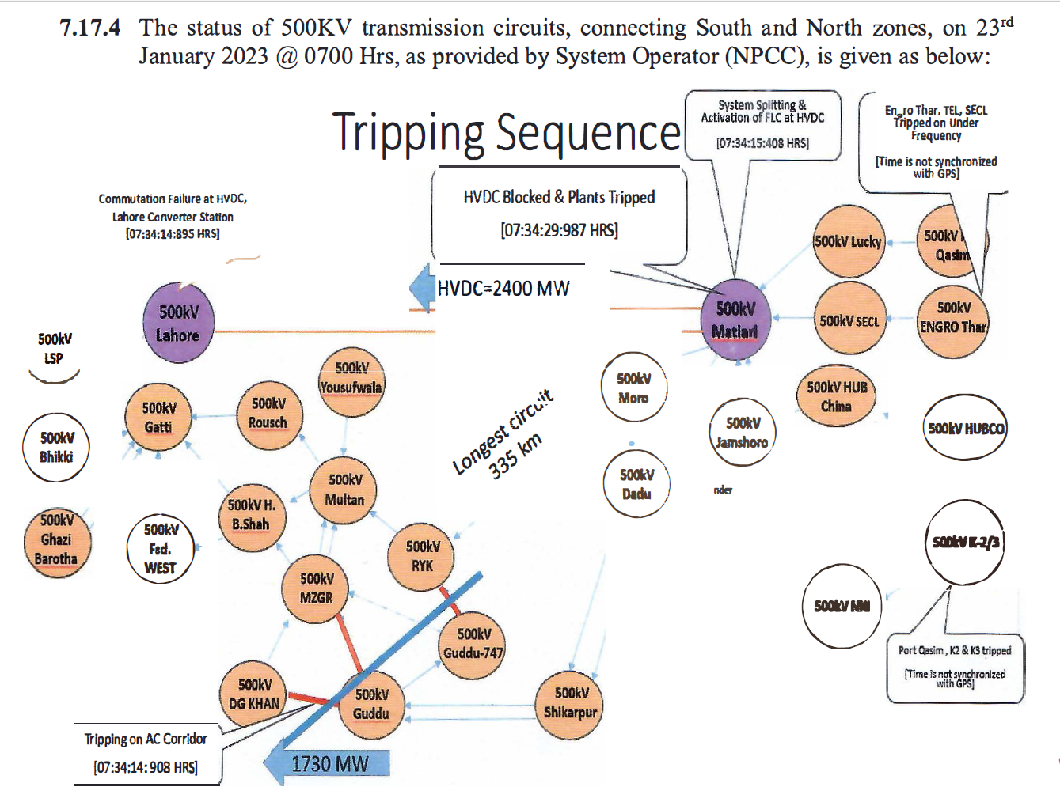

**Event Occurrence:**

1. 07:30 Hrs, wind generation curtailment lifted, and as a result about 500 MW generation injected in the system, which caused the overloading of transmission lines as well as low voltage under steady state conditions in view of long AC Corridor of about 1100 Km, from Thar in South to Haveli Bahadur Shah in North with insufficient VAR generation, as the Guddu 747 Plant was under forced shutdown. This reduced the T/Line capacity in light of Surge Impedance Level (SIL). Consequently, apart from rising trend in system frequency due to increase in wind generation, the oscillations on the system also started.
2. 07:32:22:187 Hrs, the generation in Northern region was reduced by shutdown of the one unit and ramp down the generation of another unit of Ghazi Brotha. This action aggravated the situation as system was already weak and under stress due to high AC flow and low voltage/ lass VAR compensation in middle.
3. 07:33:36 Hrs, NPCC detected system oscillation.
4. 07:34:14:895 Hrs, the initiation of the event started with the depression of voltages as shown in graph of Annex-30. This increased the oscillations which can also be seen from the graphs of Multan, Lahore and Muzaffargarh attached as Annex-31. Due to these oscillations in voltage and current, the Commutation Failures at voltage 391 kV recorded at Lahore Converter Station, graph attached as Annex-32.
5. 07:34:14:908 Hrs, after 13 milli-seconds of activation of the Commutation Failure, the DC power of about 304 MW was also shifted on AC corridor. Consequently, the power swing was generated on the system. However out of step protection scheme as per attached Annex-33 for splitting the system in different Islands, did not operate. Resultantly all three HV AC circuits (Guddu-DG Khan, Guddu-Muzaffargarh, Guddu 747-RY Khan) as mentioned in Annex 33 (i) tripped on Power Swing (unstable) and HVAC system split into two regions. but both regions still remained connected through HVDC system. In view of the load flow, where about 4130-4652 MW was being exported from South to North, the splitting of the HVAC network into North and South sub-systems caused frequency rise in the Southern region up-to 51.525 Hz having excess generation and depressed frequency/voltage in Northern region having excess load.
6. 07:34:15:250 Hrs, the frequency Limit Controller (FLC) at Converter Grid Station initiated.
7. 07:34:15:408 Hrs, FLC of HVDC activated and provided a support of additional 100 MW to North to balance the frequency in both regions. Prior to that, another catastrophic factor was that Port Qasim Generating Unit # 2, in operation, started Run Back instead of tripping/ isolation from National grid at over frequency setting, implemented as 51.4 Hz (instantaneous) as per the agreed setting, attached as Annex-35, provided by the plant Management.
8. 07:34:15:417 Hrs, before completion of FLC cycle, Over Voltage protection at NKI operated and tripped 500KV NKI-Jamshoro and NKI-K2/K3 circuits from both ends. The tripping of above-mentioned circuits isolated NKI from 500 KV National Grid. Thus, the export of 521 MW to K. Electric became zero and K. E went into the Island status. Although the consequences would not have been avoided, the rejection of load of 521 MW pushed the frequency rise trend in the South region. Looking into further, it was noted that the time delay setting of over voltage low set element at NKI end for Jamshoro and NKI-K2/K3 circuits was very low i.e., 100 milli-second. After pointing out the same by committee, the above setting was revised to 8 seconds and 11 seconds on Jamshoro and K2/K3 circuits respectively and for High set elements of both the circuits from 0.00 to 0.10 sec on 24-02-2023 (Annex-34).
9. 07:34:15:568 Hrs, Murrah DC Frequency Limit Control Function (FLC) activated.
10. 07:34:15:935 Hrs, this resulted in sustained over frequency which caused tripping of K-2 (1040 MW) and K-3 (900 MW) at agreed trip setting of 50.5 Hz with time delay of 0.25 sec. With the tripping of 1940 MW of K2, K3 plants, the system experienced a severe in frequency.
11. 07:34:29:987 Hrs, although about 426 MW was rejected through Under Frequency Load Shedding scheme in South region, but being insufficient, caused HVDC system to block. Resultantly cascaded outages of power plants started in South i.e., Lucky Power (606 MW), Engro Thar (150 MW), Shanghai Electric (1230 MW), and Thar Energy Limited (151 MW) on under-frequency protection, and thus the collapse of NTDC Southern Island.
12. 07:34:43:800 Hrs, the export to KE from NTDC 220 KV network (Jhimpir Grid) became zero. In the meantime, the North region also collapsed in spite of load rejection of 3834 MW through Automatic Load Shedding Scheme i.e., Under Frequency, Under Voltage and Rate of Change of Frequency (ROCOF). With regards to KE, prior to the event, it was running synchronized with NTDC. Major portion of its network, including all its generation, was connected with NKI and the other portion with 220 KV NTDC Jhimpir-II grid station. KE total load was 1246 MW, out of which 708 MW import from NTDC (NKI-521 MW and Jhimpir II-187 MW), and the remaining 538 MW from its own generation (BQPS III-498 MW and SNPC-40 MW). KE faced deficiency of 521 MW, however, the NKI-KE Cross Trip Scheme operated which rejected the load of 283 MW from KE network. Since the power deficit was still there, the under-frequency scheme operated through which 341 MW was rejected. Thus, a total of 624 MW was rejected against short fall of 521 MW so KE system should have sustained but Unit # 10 (249 MW) of BQPS-III tripped on ‘Combustion Chamber Acceleration’ which does not seem to be justified. This caused the other Unit # 20 (239 MW) of BQPS III and SNPC (40 MW) to trip on over loading. Upon collapse of NTDC network, export from 220 KV Jhimpir-II became zero. Thus, KE system completely collapsed.

**Analysis:**

1. Although the addition of Wind generation was not required, however, if added then prior to it firing angle at HVDC should have been adjusted for additional transmission to avoid any effect on HVAC transmission lines.
2. Out of Step Devices installed in the system did not operate, which could have split the network in different stable Islands.

**Findings:**

1.Reduced line voltage at North caused Commutation Failure which temporarily decreased power flow from HVDC Lahore converter station.

2. Some power of HVDC was diverted to HVAC which generated Power Swing.

3. Out of step protection schemes did not operate , hence North and South zones split on HVAC system. However both zones remained connected through HVDC.

**Conclusion:**

**Responsibility for the countywide blackout**

For non-activation of Out of Step Splitting System

**Remedial measures/recommendations:**

1. The stability of HVDC system needs to be ensured through proper study to avoid

frequent signals of ‘Commutation Failure'.

1. NTDC staff needs to be trained for thorough understanding of HVDC transmission

system.

1. NTDC shall ensure the healthiness and operation of recently installed Out Of Step

devices，as the same did not operate during the event.